Air Quality Technologies

Case Study

Submitted By:

Tony Trotter

9/13/2022

Summary

Air Quality Industries (AQI) has interesting, patented technology. However, it *doesn’t* have any actual sales data, any customer feedback information, product durability statistics, etc. Therefore, it is difficult to gauge what the authentic demand for their product would be. In its pro forma financials, AQI projects sales growth of 110% compounded annually for 5 years for its Cleen-Aire Sytem5 units. In my opinion, these numbers are so unrealistic they appear desperate.

AQI’s pro forma financials anticipate sales going from $0 to $113mm in just 5 years. These remarkable sales would put AQI in league with Apple computer and other historic VC success narratives.

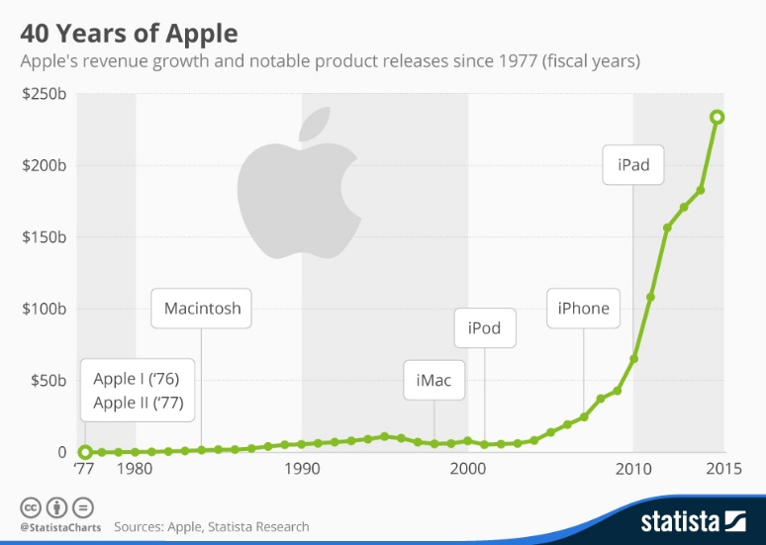Instead, it looks like AQI is a story that went bad. It that started with promising tech but was underfunded and poorly managed. AQI looks in many respects like a hobby that got expensive and now the founders need something to happen to recoup losses. A business plan was thrown together with high projections, and the hope is that someone will bail them out. However, times are different than they were in 1999. The industry appears to have moved beyond the Cleen-Aire system5.

**Recommendation**

It is my recommendation that a VC offer to buy the Cleen-Aire system5 technology for $100k. I then think a new and experienced management team should conduct a series market studies to see if there are instances where the system5 set of technologies would make sense as an addition or component to existing industrial filtration technologies already in the market. I think it’s likely that an existing industrial filtration manufacturer would then buy the system5 set of technologies for 3-5x the purchase price of 100k.

S.W.O.T Analysis

I am impressed by AQI’s patented filtration technology and overall filtration system. Additionally, there is a very large and growing market for industrial filtration solutions.

However, top management at AQI does not have the skill set that is aligned with bringing the system5 technology to market in a way that will maximize its economic potential.

Similarly, the Cleen-Aire System5 configuration lacks social proof. We need actual customer feedback on the performance of the machines. Also, we need additional laboratory testing to tell us more about how successful the machine is in doing its job over time and in a real-world setting. There is embedded competition in this space with sophisticated technology. It is unclear at this point how AQI expects to become the industry’s dominant player with the aforementioned constraints.

Risk Analysis

Product

AQI flagship product is the Cleen-Aire Sytem5 Processor. The company also plans to market the Steril-Air System5 product line which comes in both upright and horizontal and AC or DC configurations. AQI also has a series of ancillary products such as:

* Service contracts
* Environmental evaluation kits
* Special filter medias
* “Fit & Clean” image builder program
* Proprietary aerosol

AQI has an interesting 5-stage filtration system. They have provided some evidence that indicates their product is able to filter at a rate that is beyond the competition. However, more testing is required to verify these claims. For example, at what rate per cubic foot does a Cleen-Aire System5 unit clean to greater than 90-95% efficacy?

Currently, the industry standard appears to be bi-polar ionization systems. They are used inside the HVAC systems of hospitals and other businesses worldwide removing 97% of allergens, germs, VOC’s, and pathogens in as little as 30 minutes.[1]

Market

AQI claims in its business plan that the current domestic (U.S.A.) market for portable air-purification approaches 1.5 billion dollars annually. However, the domestic market for industrial air purification is closer to 30 billion and is expected grow to over 35 billion by 2031.

However, the industry standard is currently one or more variants of the bi-polar ionization technology that is placed inside an HVAC system coupled with a HEPA or series of HEPA filters. There may be a market for the filtration system used by the Cleen-Aire unit, but it is unclear how large that market might be without doing additional market research.

Team & Execution.

**Bruce R. Searle** -CTO is the developer of the Cleen-Aire set of technologies. However he has most of his experience in mortgage banking and real estate development. These attributes do not make him a good fit for bringing a startup to market in the industrial filtration space. I recommend replacement.

**Jim Wood** -COO has 33 years of leadership and management experience in the United States Army. Mr. Wood’s experience does not make him qualified to run operations in an industrial filtration company. I recommend replacement.

**Hartmut Kuno** -Chief of Marketing Mr. Kuno has a master’s degree in advertising psychology as well as 13 years of related industry experience. Mr. Kuno does appear to have the experience and education necessary to successfully serve in a marketing role at AQI. I recommend keeping Mr. Kuno.

**Richard Von Clause** -Chief Production Engineer Mr. Clause holds a BS in Mechanical Engineering from University of Chicago and has been involved in the development and manufacture of high-tech products and component parts since 1975. Mr. Clause is an experienced mold and die maker, planning engineer, and project supervisor. He does appear to have the education and experience to serve as a production engineer. I recommend keeping Mr. Clause.

Financial

Negative retained earnings can be an indicator of bankruptcy since it implies a long-term series of losses. Are the negative retained earnings an indicator as to why the pro forma financials are so *desperately* optimistic?

**Quantitative Analysis**

Valuation and Hurdle Rate

AQI’s 5-year proforma income statement is *very* optimistic. For example, the CAGR for total sales years 1 through 5 is **110.09%**. Therefore, *if* we accept AQI’s proformas as being plausible, we arrive at an NPV of **$1,483,019** and an IRR of **153.89%**. See below:

Similarly, depending on the methodology used, I achieved a range of values for the hurdle rate. I think it would be prudent for me to require the highest calculated hurdle rate for my money.

Therefore, I settled on **41.17%** ownership of **$1,483,019** for a seed investment of $1mm.

Capital Structure

The **proposed equity ownership** structure post capital investment is outlined in the pie chart to the **left**.

The new ownership structure represents a dilution of equity by the founders of **41.17%**, but it represents an accretion in firm value from **$44,181** to **$1,483,019**.

Similarly, if I as the VC were to invest $1mm in year 0 and accept **41.17%** of the company’s income over time, I would generate an IRR of ≈**100%** see below:

Simple Analysis

The cursory analysis I conducted when looking at AQI’s financials was to look at their 5-year projected revenues post capital infusion. See below:

The first problem I noticed was that AQI has proforma sales that anticipate a compound annual growth rate (CAGR) of over **110%** for 5 years. This is particularly unrealistic given that the firm hasn’t sold a single unit ever. It then follows that any valuation and hurdle rate that are based on these unrealistic projected sales are called into question.

After conducting a deep analysis of industrial filtration sector growth from 2022-2031, MarketWatch states the following:

**"The industrial filtration market is projected to grow at a CAGR of 6.50% from 2022 to 2031."[2]**

I reduced revenues in AQI’s proforma 5-year income statement from a CAGR of over **110%** to a CAGR of **27.82%**. See Below:

When sales are reduced to a level that is more in line with industry expectations, hurdle rates expand to a level that make a VC investment as requested by the business plan impossible.

Complex Analysis

**Profitability**

Upon doing a deep dive into AQI’s pro forma financials, its worth mentioning that not only are their sales overstated, but every measure of profitability has an unrealistic positive trajectory upward.

**Cash Management**

It is generally considered poor cash management to have more than **8-10%** of cash as a percentage of sales on hand at any point in time. AQI projects it will have **18.6%** up to **78.3%** of cash as a percentage of sales on hand and hundreds of days’ worth of cash on hand in years **2-5**.

**Working Capital Management**

The most egregious aspect of AQI’s pro forma financials was its Days Sales Outstanding and its projected Cash Conversion Cycle. Days Sales Outstanding represents the average number of days it takes credit sales to be converted into cash or how long it takes a company to collect its account receivables. *Forty-five days* is considered average. AQI has days sales outstanding that range from **2799** in year two to **664** in year five. Similarly, The Cash Conversion Cycle is a metric that shows the amount of time in days it takes a company to convert its investments in inventory to cash. AQI’s projected cash conversion cycle is out of control as it ranges from **2834** day in year two to **714** days in year five.

1. Energy Professionals. “What is Bi-Polar Ionization?”. Web. 9/12/2022. [What is Bi-Polar Ionization? - Energy Professionals | Leading Energy Advisers](https://energyprofessionals.com/what-is-bi-polar-ionization/)
2. MarketWatch. “Industrial Filtration Market Size”. Web. 7/11/2022. [Industrial Filtration Market Size, Share, Emerging Trends, Leading Key Players, Future Growth, Revenue, Demand Forecast, Product Type, Revenue Forecast to 2022-2031 - MarketWatch](https://www.marketwatch.com/press-release/industrial-filtration-market-size-share-emerging-trends-leading-key-players-future-growth-revenue-demand-forecast-product-type-revenue-forecast-to-2022-2031-2022-07-11#:~:text=The%20market%20for%20air%20filtration%20is%20expected%20to,gaining%20importance%20and%20is%20contributing%20to%20its%20development.)